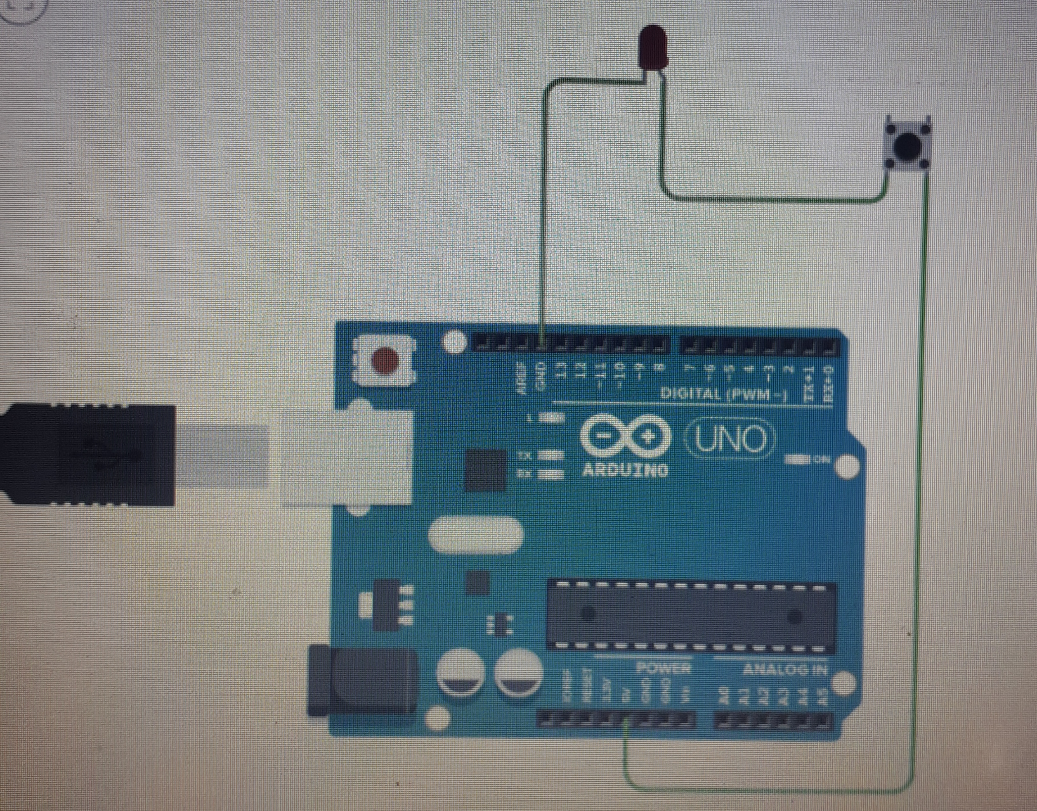

**Theory:**

Concept used:As the task says the lights inside the almirah turns on when we open it and turns off as we close it. So as we open the door the circuit of becomes closed and stays closed until we closed the door.

Learning and observation: learned about connecting circuits and the mechanism used in this task.

Problems and troubleshooting: the problem encountered was int the idea genetration but then the concept used in refrigerators gave a hint.

Precautions:

1. The lights should stay on till the switch is kept pressed.

Learning Outcomes: As the door opens the switch is pressed and the lights turns on and stays on till the switch is pressed , means till the door is opened. The when the door is closed the switch is pressed off and light turns off ?